**Lab 7,8 : DHCP hdcp relay Agent**

Trên máy ảo gốc (VMNet2), clone các máy ảo (1G) Client1 (VMNet2), Client2(VMNet3), DHCPRELAYS như routor (VMNet2) (VMNet3)

**1, Cài đặt các dịch vụ** : trên Censos1 và Centos2

Bật mang chế độ automatic

**Cài DHCP** : yum install dhcp -y Kiểm tra dịch vụ : rpm -qa|grep dhcp

Cài Bind : yum install bind -y Kiểm tra dịch vụ : rpm -qa|grep bind

Cài httpd : yum install httpd -y

yum install telnet -y

[root@ndduc ~]# rpm -qa|grep postfix

[root@ndduc ~]# rpm -qa|grep squirrelmail

[root@ndduc ~]# yum install epel-release -y

yum install squirrelmail -y

**Tiến hành :**

**Cấu hình ip tĩnh trên centos 1**

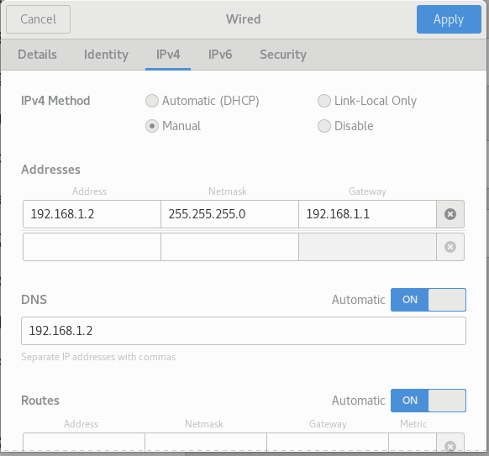

**Mở tệp** : dhcpd.conf gedit /etc/dhcp/dhcpd.conf

**Đè tệp :** cp /usr/share/doc/dhcp-4.2.5/dhcpd.conf.example /etc/dhcp/dhcpd.conf

**Trong file vừa copy**  
option domain-name "ndduc.vn";

option domain-name-servers ns1.ndduc.vn;

Xóa

subnet 10.152.187.0 netmask 255.255.255.0 {

}

**Chỉnh :**   
#cap cho lan 1

subnet 192.168.1.0 netmask 255.255.255.0 {

range 192.168.1.100 192.168.1.200;

option routers 192.168.1.1;

option domain-name-servers 192.168.1.2;

}

# This declaration allows BOOTP clients to get dynamic addresses,

# which we don't really recommend.

#cap cho lan 2

subnet 10.0.0.0 netmask 255.255.255.0 {

range 10.0.0.2 10.0.0.254;

option routers 10.0.0.1;

option domain-name-servers 192.168.1.2;

}

**Kiểm tra** : service dhcpd start

[root@ndduc ~]# service dhcpd start

Redirecting to /bin/systemctl start dhcpd.service

**Mở Client 1**

Không Cài ip   
[root@ndduc ~]# service network restart

Restarting network (via systemctl): [ OK ]

Ip a

**Trên máy chính kiểm tra bằng cách (Ảnh lấy điểm) :**

cat /var/lib/dhcpd/dhcpd.leases

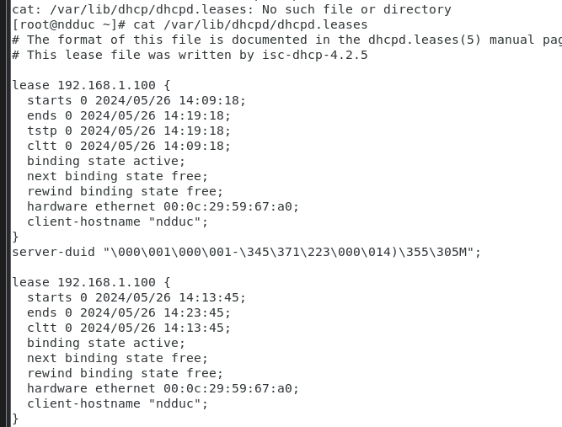

**Mở Centos2**

Đảm bảo cài các dịch vụ dhcp, bind

Cấu hình router ens33. ens36

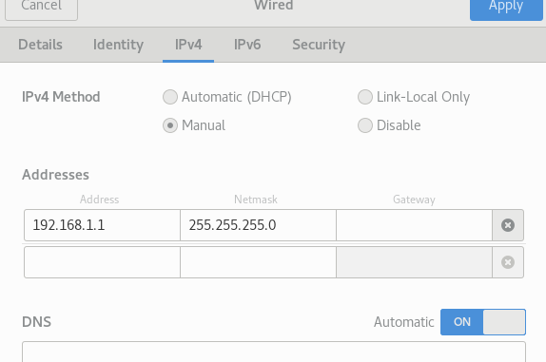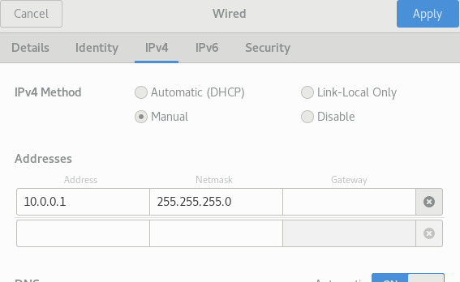

[root@ndduc ~]# cp /lib/systemd/system/dhcrelay.service /etc/systemd/

[root@ndduc ~]# gedit /etc/systemd/dhcrelay.service

Trong file đó : ExecStart=/usr/sbin/dhcrelay -d --no-pid 192.168.1.2

Trong file **/usr/lib/systemd/system/dhcrelay.service** ExecStart=/usr/sbin/dhcrelay -d --no-pid 192.168.1.2

**Tạo 1 file** có nội dung bên dưới lưu trong /etc/systemconf/dhcrelay  
DHCPINTERFACES="ens33"

DHCPSERVER="192.168.1.2"

**Thực hiện các câu lệnh**[root@ndduc ~]# systemctl enable dhcrelay

Created symlink from /etc/systemd/system/multi-user.target.wants/dhcrelay.service to /usr/lib/systemd/system/dhcrelay.service.

[root@ndduc ~]# systemctl --system daemon-reload

[root@ndduc ~]# systemctl --system daemon-reexec

[root@ndduc ~]# systemctl force-reload dhcrelay.service

[root@ndduc ~]# systemctl restart dhcrelay.service

[root@ndduc ~]# systemctl status dhcrelay.service

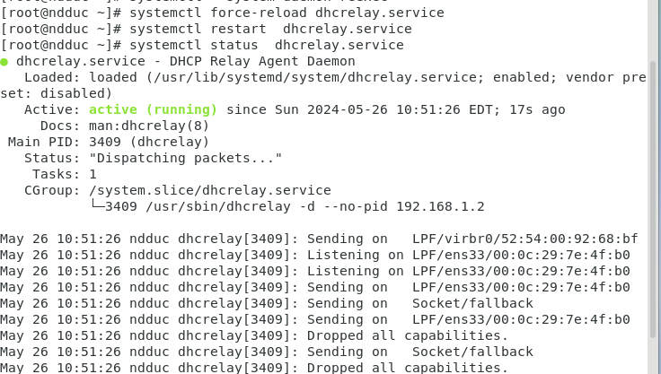

**Mở Client2** để test bằng

**Ip a**

**Quay trở lại máy chính**

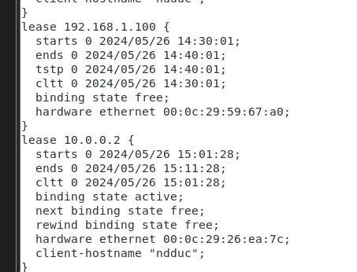

**Lab 9 : DNS WEB MAIL liên miền**

**Làm ndduc.thi**

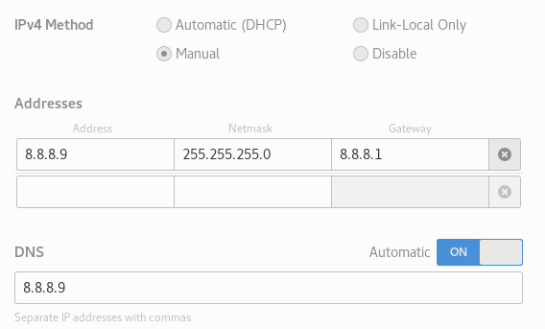

**Vào** file : gedit /etc/named.conf

**Sửa**

listen-on port 53 { any; };

listen-on-v6 port 53 { ::1; };

directory "/var/named";

dump-file "/var/named/data/cache_dump.db";

statistics-file "/var/named/data/named_stats.txt";

memstatistics-file "/var/named/data/named_mem_stats.txt";

recursing-file "/var/named/data/named.recursing";

secroots-file "/var/named/data/named.secroots";

allow-query { any; };

forwarders {8.8.8.8;};

#include "/etc/named.rfc1912.zones";

#include "/etc/named.root.key";

**Thêm**

zone "ndduc.thi" IN {

type master;

file "ndduc.thi.dns";

};

zone "8.8.8.in-addr.arpa" IN {

type : master;

file "8.8.8.dns";

};

**Thêm file**

/var/named/ndduc.thi.dns

$TTL 86400

@ IN SOA ns.ndduc.thi. root.ndduc.thi. (

1

2

3

4

5 )

IN NS ns.ndduc.thi.

IN MX 10 mail.ndduc.thi.

ns IN A 8.8.8.9

www IN A 8.8.8.9

mail IN A 8.8.8.9

/var/named/8.8.8.dns

$TTL 86400

@ IN SOA ns.ndduc.thi. root.ndduc.thi. (

1

2

3

4

5 )

IN NS ns.ndduc.thi.

9 IN PTR mail.ndduc.thi.

LÀM WEB

Tạo 1 file index.html /var/www/html/index.html

<html>

<body>

<h1 aligh=center style=color:red>Welcome to NhuDinhDuc's Website!</h1>

</body>

</html>

**Truy cập** /etc/postfix/main.cf

Sửa   
#myhostname = host.domain.tld

myhostname = mail.ndduc.thi

mydomain = ndduc.thi

myorigin = $mydomain

inet_interfaces = all

#inet_interfaces = $myhostname

#inet_interfaces = $myhostname, localhost

#inet_interfaces = localhost

#mydestination = $myhostname, localhost.$mydomain, localhost

mydestination = $myhostname, localhost.$mydomain, localhost, $mydomain

#mydestination = $myhostname, localhost.$mydomain, localhost, $mydomain,

mynetworks = 8.8.8.0/24, 127.0.0.0/8

home_mailbox = Maildir/

**Truy cập** gedit /etc/dovecot/dovecot.conf

# Protocols we want to be serving.

protocols = imap pop3 lmtp

**Truy cập** gedit /etc/httpd/httpd.conf

Dán đoạn code sau  
Alias /webmail /usr/share/squirrelmail

<Directory /usr/share/squirrelmail>

Options Indexes FollowSymLinks

RewriteEngine On

AllowOverride All

DirectoryIndex index.php

Order allow,deny

Allow from all

</Directory>

**Terminal mà mới**   
[root@ndduc ~]# systemctl start named

[root@ndduc ~]# systemctl status named

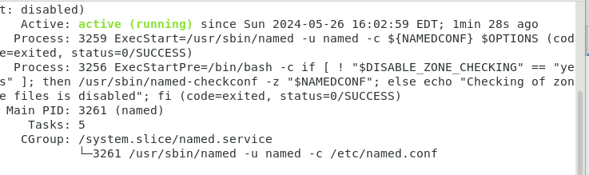

**Lên fireFox test tên miền ndduc.thi**

**Cấu hình squirrel (Lỗi tạm ngưng)**

[root@ndduc ~]# cd /usr/share/squirrelmail/config/

[root@ndduc config]# ll

[root@ndduc config]# ./conf.pl

**Xem video thao tac**

<http://mail.ndduc.thi/webmail/src/redirect.php>

lỗi

[root@ndduc config]# vi /etc/selinux/config

[root@ndduc config]# systemctl stop firewalld

[root@ndduc config]# systemctl status firewalld

**Cài telnet :**

[root@ndduc config]# telnet

telnet> ^C

[root@ndduc config]# netstart -an | grep *:25

[root@ndduc config]# systemctl restart postfix

[root@ndduc config]# telnet mail.ndduc.thi 25

Trying 8.8.8.9...

Connected to mail.ndduc.thi.

Escape character is '^]'.

220 mail.ndduc.thi ESMTP Postfix

helo ndduc.thi

250 mail.ndduc.thi

mail from:root

250 2.1.0 Ok

rcpt to:ndduc

250 2.1.5 Ok

data

354 End data with <CR><LF>.<CR><LF>

chao ban duc

.

250 2.0.0 Ok: queued as 2388D229FB0F

**[root@ndduc ~]# telnet mail.ndduc.thi 110**

Trying 8.8.8.9...

Connected to mail.ndduc.thi.

Escape character is '^]'.

+OK Dovecot ready.

user ndduc

+OK

pass ducnhu1234

+OK Logged in.

1 398

-ERR Unknown command: 1

list

+OK 1 messages:

1 387

.

retr 1

Clone máy ảo lab.com qtm.com

**Trên máy lab.com**

Trong file named.conf

zone "lab.com" IN {

type master;

file "lab.com.dns";

};

Trong lab.com.dns

$TTL 86400

@ IN SOA ns.lab.com. root.lab.com. (

1

2

3

4

5 )

IN NS ns.lab.com.

IN MX 10 mail.lab.com.

ns IN A 8.8.8.10

www IN A 8.8.8.10

mail IN A 8.8.8.10

$TTL 86400

@ IN SOA ns.lab.com. root.lab.com. (

1

2

3

4

5 )

IN NS ns.lab.com.

10 IN PTR mail.lab.com.

**Trong terminal**

[root@ndduc ~]# systemctl start named

[root@ndduc ~]# systemctl enable named

[root@ndduc ~]# systemctl enable httpd

[root@ndduc ~]# systemctl start httpd

[root@ndduc ~]# systemctl start postfix

[root@ndduc ~]# systemctl start dovecot

[root@ndduc ~]# useradd lab

[root@ndduc ~]# passwd ducnhu1234

passwd: Unknown user name 'ducnhu1234'.

[root@ndduc ~]# useradd lab

useradd: user 'lab' already exists

[root@ndduc ~]# passwd lab

Changing password for user lab.

New password:

Retype new password:

passwd: all authentication tokens updated successfully.

[root@ndduc ~]# systemctl restart named

[root@ndduc ~]# service firewalld stop

Redirecting to /bin/systemctl stop firewalld.service

[root@ndduc ~]# nslookup mail.lab.com

Server: 8.8.8.10

Address: 8.8.8.10#53

Name: mail.lab.com

Address: 8.8.8.10

[root@ndduc ~]#

[root@ndduc ~]# telnet mail.lab.com 25

Trying 8.8.8.10...

Connected to mail.lab.com.

Escape character is '^]'.

220 mail.lab.com ESMTP Postfix

helo lab

250 mail.lab.com

mail from:root

250 2.1.0 Ok

rcpt to:lab

250 2.1.5 Ok

data

354 End data with <CR><LF>.<CR><LF>

hell lab

.

250 2.0.0 Ok: queued as 23191229FB07

[root@ndduc ~]# telnet mail.lab.com 110

Trying 8.8.8.10...

Connected to mail.lab.com.

Escape character is '^]'.

+OK Dovecot ready.

user lab

+OK

pass ducnhu1234

+OK Logged in.

list

+OK 1 messages:

1 360

.

retr 1

+OK 360 octets

Return-Path: <root@lab.com>

X-Original-To: lab

Delivered-To: lab@lab.com

Received: from lab (mail.lab.com [8.8.8.10])

by mail.lab.com (Postfix) with SMTP id 23191229FB07

for <lab>; Sun, 26 May 2024 17:44:43 -0400 (EDT)

Message-Id: <20240526214517.23191229FB07@mail.lab.com>

Date: Sun, 26 May 2024 17:44:43 -0400 (EDT)

From: root@lab.com

hell lab

.

**Trên máy qtm.com**

zone "ndduc.thi" IN {

type master;

file "ndduc.thi.dns";

};

zone "lab.com" IN {

type master;

file "lab.com.dns";

};

zone "qtm.com" IN {

type master;

file "qtm.com.dns";

};

Tạo thêm file

service start named

service start dovecot

service start httpd

service start postfix

service firewalld stop